Developing your understanding 16.10
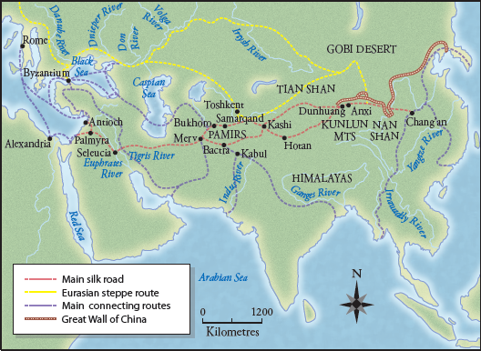
Source 16.17 The main routes of the Silk Road and the Eurasian steppe route

1 List four pieces of information you can gain from Source 16.17.

2 What does Source 16.17 suggest about why Chinese silk was seen as superior to that from other places?

